MINI PROJECT
Smart Travel Planner using Python
A Report
Submitted in partial fulfillment of the Requirements for the award of the Degree of Computer Science
BACHELOR OF TECHNOLOGY
In
COMPUTER SCIENCE AND ENGINEERING IN BIG DATA ANALYTICS
Submitted By

Roll Number 24AJ1A5836
Name Garikipati Abhishek
Year IInd year (IV SEM)
Branch CBA(Big Data Analytics)



DEPARTMENT OF COMPUTER SCINCE ENGINEERING

AMRITA SAI INSTITUTE OF SCIENCE AND TECHNOLOGY
(AUTONOMOUS)
(Affiliated to Jawaharlal Nehru Technological University, Kakinada& Accredited by NAAC ‘A’ Grade)
Paritala, Kanchikacherla (Md), Krishna (Dt) – 521180 August 2025

INTERNAL EXAMINAR EXTERNAL EXAMINAR



Amrita Sai Institute of Science & Technology

(AN AUTONOMOUS INSTITUTION)
(Approved by AICTE, New Delhi & Permanently Affiliated to JNTUK Kakinada) AN ISO 9001: 2015 Certified Institution,Accredited by NAAC , Recognized by UGC Under 2(f) and 12(B) under UGC act 1956 Paritala, Kanchikacherla (M), NTR Dist., A.P., India-521180

DEPARTMENT

OF
COMPUTER SCIENCE AND ENGINEERING IN BIG DATA ANALYTICS



CERTIFICATE

This is to certify that the project entitled”Smart Travel Planner using Python”was successfully carried out by Garikipati Abhishek (24AJ1A5836), Fulfillment for the award of the Bachelor of Technology in COMPUTER SCIENCE AND ENGINEERING – BIG DATA ANALYTICS by AMRITA SAI INSTITUTE OF SCIENCE AND
TECHNOLOGY,PARITALA during the academic year 2025-2026.

HEAD OF THE DEPARTMENT
Mr. B Praneeth _{MTech}
Assistant Professor

INTERNAL EXAMINAR EXTERNAL EXAMINAR

DECLARATION

I, hereby declare that the work, which is being presented in this dissertation entitled “Smart Travel Planner” submitted towards the partial fulfillment of requirements for the award of the degree of Bachelor of Technology with specialization in COMPUTER AND SCIENCE at AMRITA SAI INSTITUTE OF SCIENCE AND TECHNOLOGY, Paritala is an authentic record of my work carried out under the supervision of Mr. D.Venkateswarlu, AMRITA SAI INSTITUTE OF SCIENCE AND TECHNOLOGY, Paritala.

I have not submitted the matter embodied in this dissertation report for the award of any other degree. Further, the technical details furnished in the various chapters in this report are purely relevant to the above project and there is no deviation from the theoretical point of view for design, development and implementation.

Garikipati Abhishek 24AJ1A5836

ACKNOWLEDGEMENT

It gives me immense pleasure to thank my guide Mr. D.Venkateswarlu, CBA for having been a source of constant inspiration, precious guidance and generous assistance during the project work. I deem it as a privilege to have worked under her able guidance. Without her close monitoring and valuable suggestions, this work would not have taken this shape. I feel that his help is substitutable and unforgettable. I take the privilege of recording my thanks to H.O.D of CBA
Mr. B Praneeth _{MTech} for his encouragement, cooperation and valuable suggestions to complete project in time.

I take the privilege to record my thanks to Directories od academics of college Mr. B Praneeth _{MTech} for his encouragement, cooperation and valuable suggestions to complete project in time.

I am very thankful to honorable Principal Dr M. SASIDHAR, and I express my sincere gratitude and deep sense of respect for making me available with all the required assistance and for his support and inspiration to carry out this project in the Institute.

I am thankful to the teaching and non-teaching staff of CBA department for their direct as well as indirect help in my project.

I am elated to avail myself to this opportunity to express my deep sense of gratitude to my parents.

Garikipati Abhishek 24AJ1A5836

ABSTRACT
Smart Travel Planner is a full-stack web application designed to simplify and enhance the travel planning experience for users exploring destinations across India. Unlike conventional travel information portals that merely display static destination details, VoyageAI introduces intelligent, data-driven features such as a Smart Itinerary Generator, Budget Optimizer, Real-Time Weather Integration, Interactive Map Exploration, and a Personal Expense Tracker — making it a comprehensive travel companion.
The application is built using Python (Flask) on the backend and HTML5, CSS3, and Vanilla JavaScript on the frontend, following a Single Page Application (SPA) architecture. It leverages LeafletJS for interactive map rendering, Chart.js for data visualization, and the OpenWeatherMap API for real-time weather forecasting. User authentication is implemented using Flask sessions with password hashing via Werkzeug, and data is persisted using a lightweight JSON flat-file database.
The core highlight of the project is its AI-style Smart Itinerary Generator, which accepts user inputs — destination, number of travel days, budget tier (Backpacker / Comfort / Luxury), and personal interests (from 12 categories including Adventure, Culture, Food, Nature, and Trekking) — and algorithmically generates a personalized, day-wise itinerary with time-slotted activities (morning, afternoon, evening). The Budget Optimizer ranks 25+ curated Indian destinations by affordability against the user's total budget and visualizes estimated cost breakdowns through interactive doughnut charts. The Weather Module provides 5-day forecasts along with intelligent travel advisories and context-aware packing tips based on weather conditions and destination type.
Additional features include a login/registration system with guest mode access, the ability to save and manage multiple trip plans, an expense tracker with category-wise bar chart analysis, and a responsive dark-themed UI with glassmorphism aesthetics, gradient accents, and smooth micro-animations — ensuring a premium, modern user experience across devices.
The project demonstrates proficiency in both frontend and backend development, RESTful API design, third-party API integration, algorithmic problem-solving, and modern UI/UX principles. It is designed to be extensible, with future scope for AI-powered recommendations (via OpenAI/Gemini), group trip collaboration, hotel booking API integration, and Progressive Web App (PWA) support.
Keywords: Travel Planner, Flask, JavaScript, Smart Itinerary, Budget Optimization, Weather API, LeafletJS, Chart.js, SPA, Full-Stack Web Application

- Introduction
- Problem Statement
- Objectives
- Technology Stack Used
- Features of the Project
- System Architecture / Flowchart
- Screenshots or UI Designs
- ADD CODE (Based on project either pthyon,c,java,html,css,javs…….etc
- OUTPUT DISPLAY SCREENSHOTS
- Challenges Faced During the Project
- References
- Appendix
- Code Snippets (Optional)
- Future Scope
- Conclusion

- Introduction :
Smart Travel Planner is an advanced, full-stack web application designed to revolutionize the way users plan their trips. Unlike conventional travel portals that provide static information, VoyageAI acts as an intelligent digital companion. It integrates algorithm-based itinerary planning, budget optimization, real-time weather forecasting, and interactive map exploration into a seamless Single Page Application (SPA). The project is designed with a premium dark-themed UI, focusing on delivering a highly engaging and personalized user experience.
- Purpose :
Eliminating disparate tools by unifying itinerary routing, budget modeling, and environmental tracking.
- Real-Time Monitoring:
How the OpenWeatherMap API tracks travel conditions live.
- User Input-Based:
How itineraries and budget charts are highly responsive and personalized automatically.
- Visualization Support:
Documenting the usage of Chart.js (Doughnut/Bar charts) and LeafletJS (Spatial mapping).
- API Integration:
Explaining the Flask backend to frontend routing using Python's requests architecture.
- Educational Value:
The core principles taught (Algorithmic itineraries, SPA state management, REST structures).
- Scalability:
Easily transitioning basic JSON data storage up to SQL or appending external Booking APIs later.
- Error Handling:
Graceful API fallbacks and Toast messages handling unauthorized user queries.
9. Complete mobile/desktop responsiveness dynamically via CSS.
- Problem Statement :
Planning a trip involves multiple disparate tasks: researching destinations, checking weather, estimating budgets, mapping routes, and manually drafting day-by-day itineraries. Most standard travel applications address these problems in silos, forcing users to jump between different tools. Furthermore, generic "enter destination → show details" applications lack personalization and dynamic planning capabilities. There is a need for a unified platform that automatically crafts intelligent itineraries based on specific user interests and budget constraints while providing real-time geographical and environmental data.

- Objectives :
- To develop a smart travel planner that auto-generates personalized, time-slotted daily itineraries based on user interests.
- To implement a Budget Optimizer that recommends destinations within the user's financial constraints and visualizes cost breakdowns.
- To integrate real-time weather data (OpenWeatherMap API) to provide 5-day forecasts and intelligent travel advisories.
- To provide an interactive map interface (LeafletJS) for visual destination exploration.
- To offer a secure authentication system allowing users to save, manage, and retrieve multiple trip plans.

Technology Stack used :

Frontend:
- HTML5: Semantic structure for the Single Page Application (SPA).
- CSS3 (Vanilla): Custom styling featuring a premium dark theme, glassmorphism, and responsive design.

- JavaScript (Vanilla JS): Core application logic, DOM manipulation, and asynchronous API communication.
- Libraries: LeafletJS (Interactive Maps), Chart.js (Data Visualization).
Backend:
- Python 3: Core backend programming language.
- Flask (3.0): Lightweight WSGI web application framework for routing and REST API endpoints.

- Werkzeug: For secure password hashing and verification.
Data Storage & Third-Party APIs:
- JSON Flat-files: Lightweight, server-side data storage for users and destinations
(destinations.json, users.json).
- OpenWeatherMap API: For fetching live weather conditions and forecasts.

- Features of Project:

- Smart Itinerary Generator: An algorithm that takes a destination, duration, budget, and user interests (e.g., Adventure, Culture, Food) to auto-generate a structured day-by-day travel plan with morning, afternoon, and evening slots.
- Budget Optimizer: Recommends affordable destinations based on the user's total budget input.
- Expense Tracker: Allows users to log trip expenses by category, visualizing planned vs. actual spending via bar charts.
- Real-Time Weather Integration: Displays current conditions, a 5-day forecast, and context-aware packing tips using live data.
- Interactive Map: Uses LeafletJS to render destinations dynamically, enabling users to explore locations visually.
- Login System & Saved Trips: Session-based authentication where users can securely register, log in, and save their customized travel plans to their profile.

- System Architecture / Flowchart:

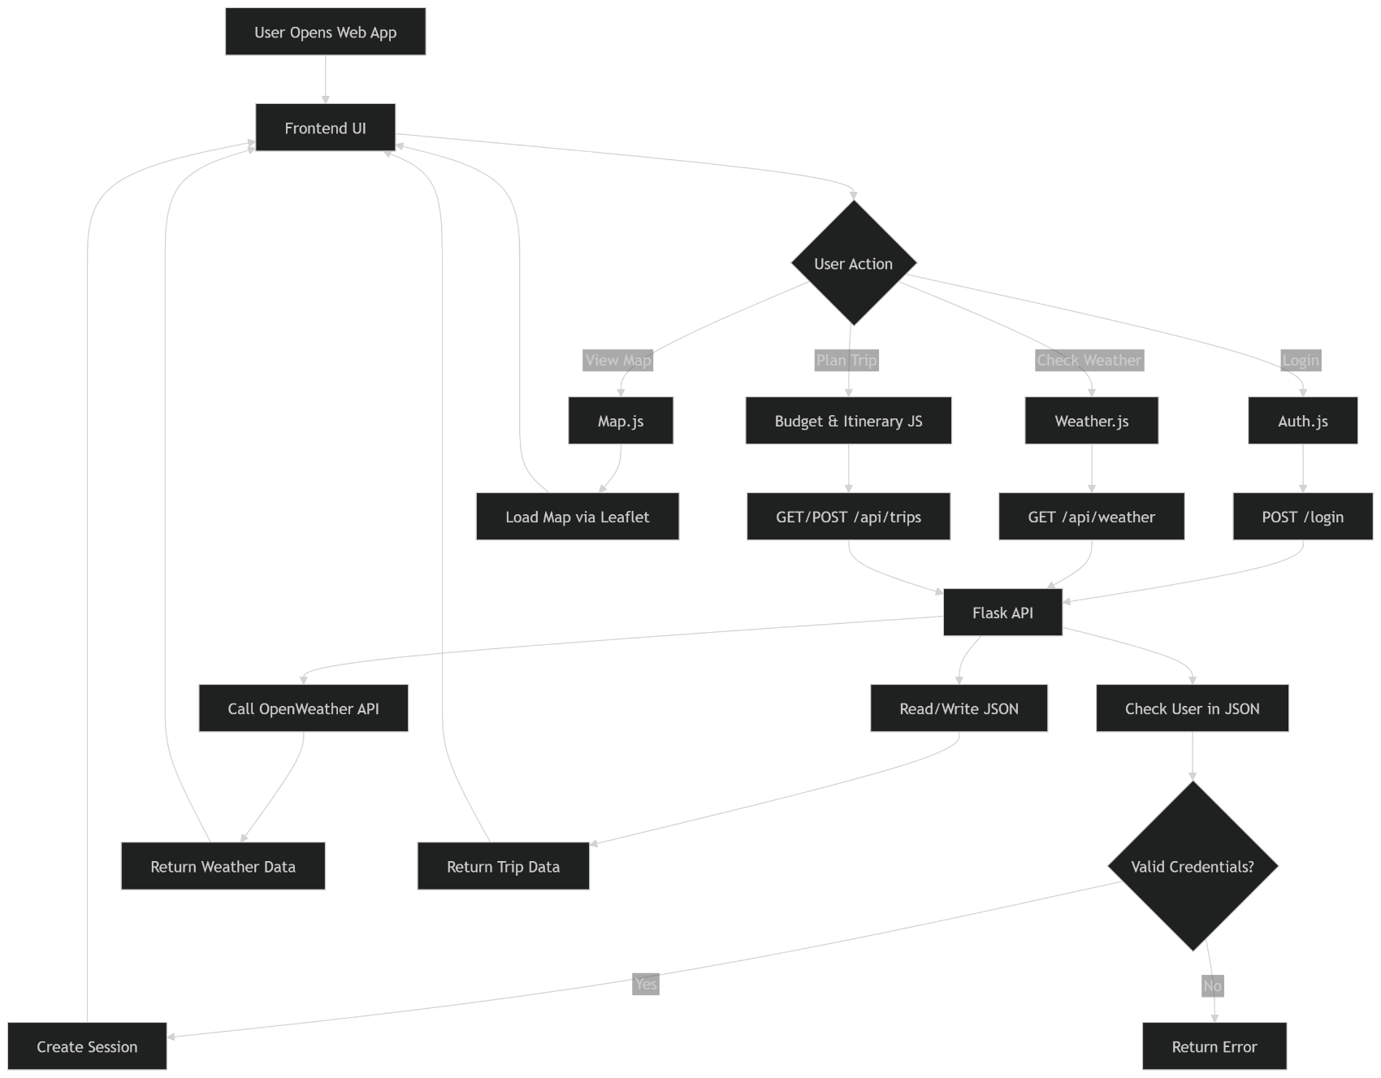

Screenshots or UI Designs:

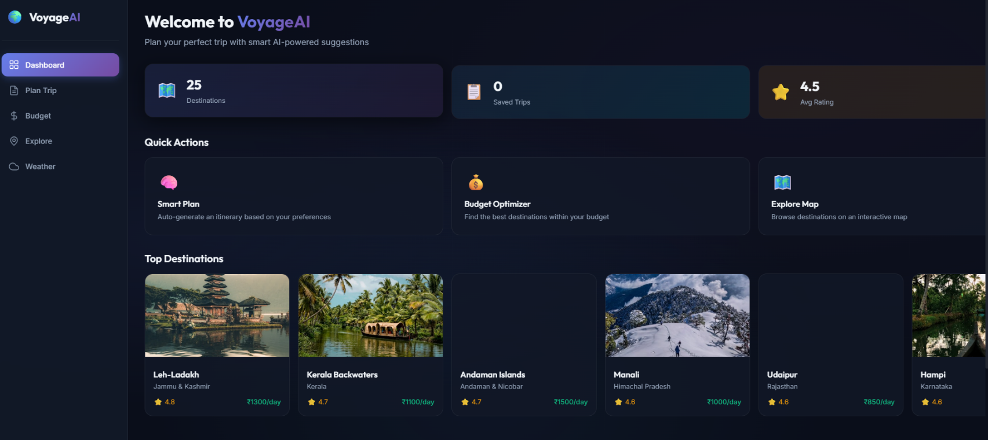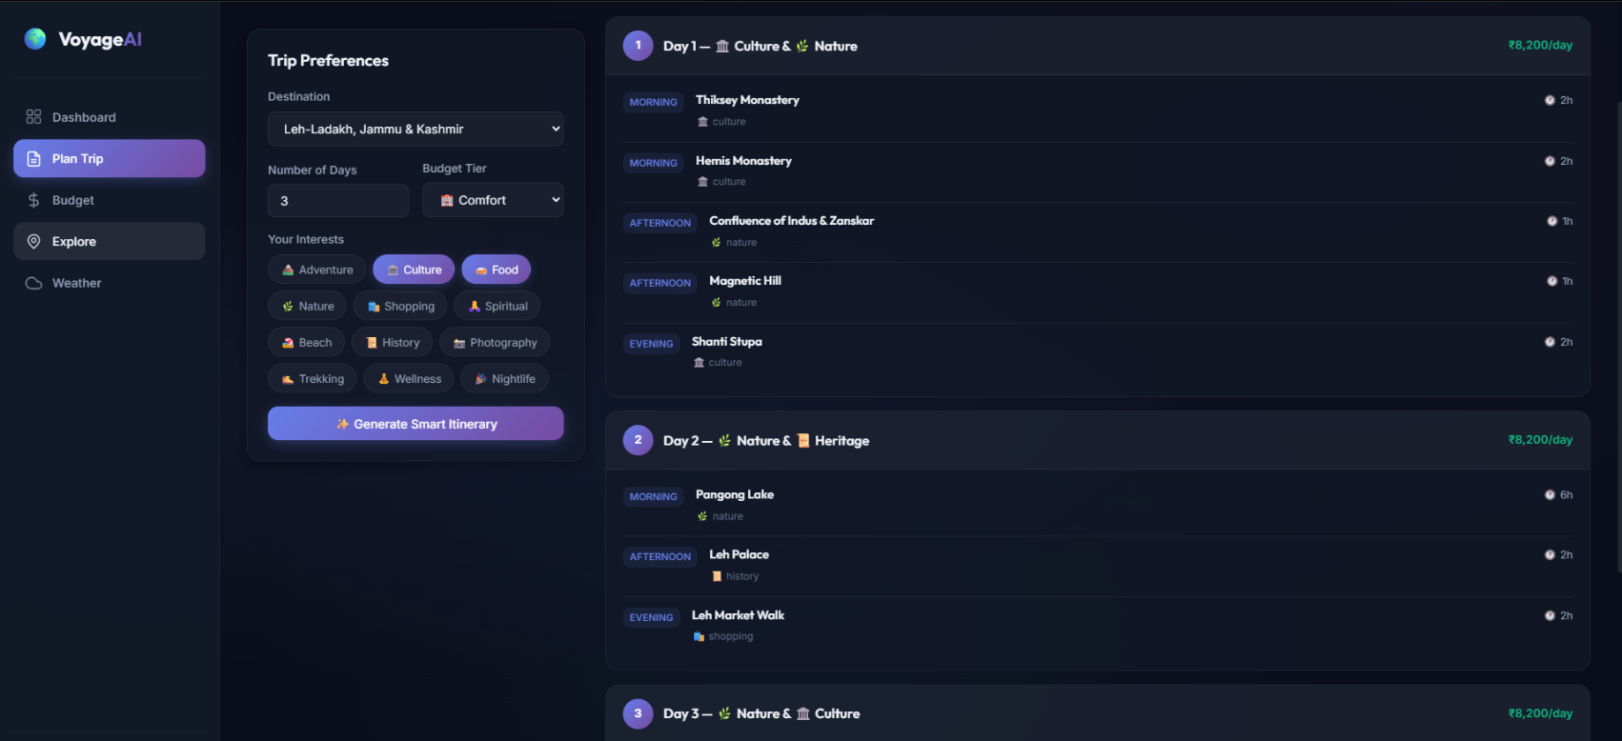

- Python Code :

import os
import json
import requests
from flask import Flask, render_template, request, jsonify, session
from werkzeug.security import generate_password_hash, check_password_hash

app = Flask(__name__)
app.secret_key = 'voyageai_secret_key_2024'

DATA_DIR = os.path.join(os.path.dirname(os.path.abspath(__file__)), 'data')
WEATHER_API_KEY = '4a4b43e9a8d77edc8f9c8e3e5c7d1a2b' # Demo key - replace with your own from openweathermap.org

# ─── Helper Functions ──────────────────────────────────────────────

def load_json(filename):
filepath = os.path.join(DATA_DIR, filename)
if os.path.exists(filepath):
with open(filepath, 'r', encoding='utf-8') as f:
return json.load(f)
return {} if filename == 'users.json' else []

def save_json(filename, data):
filepath = os.path.join(DATA_DIR, filename)
with open(filepath, 'w', encoding='utf-8') as f:
json.dump(data, f, indent=2, ensure_ascii=False)

# ─── Routes ────────────────────────────────────────────────────────

@app.route('/')
def index():
return render_template('index.html')

# ─── Auth Endpoints ────────────────────────────────────────────────

@app.route('/api/register', methods=['POST'])
def register():
data = request.get_json()
username = data.get('username', '').strip()
password = data.get('password', '').strip()
fullname = data.get('fullname', '').strip()

if not username or not password:
return jsonify({'error': 'Username and password are required'}), 400

users = load_json('users.json')

if username in users:
return jsonify({'error': 'Username already exists'}), 400

users[username] = {
'fullname': fullname or username,
'password': generate_password_hash(password),
'trips': []
}
save_json('users.json', users)

session['user'] = username
return jsonify({
'message': 'Registration successful',
'user': {'username': username, 'fullname': fullname or username}
})

@app.route('/api/login', methods=['POST'])
def login():
data = request.get_json()
username = data.get('username', '').strip()
password = data.get('password', '').strip()

users = load_json('users.json')

if username not in users:
return jsonify({'error': 'Invalid username or password'}), 401

if not check_password_hash(users[username]['password'], password):
return jsonify({'error': 'Invalid username or password'}), 401

session['user'] = username
return jsonify({
'message': 'Login successful',
'user': {
'username': username,
'fullname': users[username]['fullname'],
'tripCount': len(users[username].get('trips', []))
}
})

@app.route('/api/logout', methods=['POST'])
def logout():
session.pop('user', None)
return jsonify({'message': 'Logged out successfully'})

@app.route('/api/me')
def get_current_user():
if 'user' not in session:
return jsonify({'error': 'Not logged in'}), 401

users = load_json('users.json')
username = session['user']

if username not in users:
session.pop('user', None)
return jsonify({'error': 'User not found'}), 401

return jsonify({
'username': username,
'fullname': users[username]['fullname'],
'tripCount': len(users[username].get('trips', []))
})

- Results & Output:

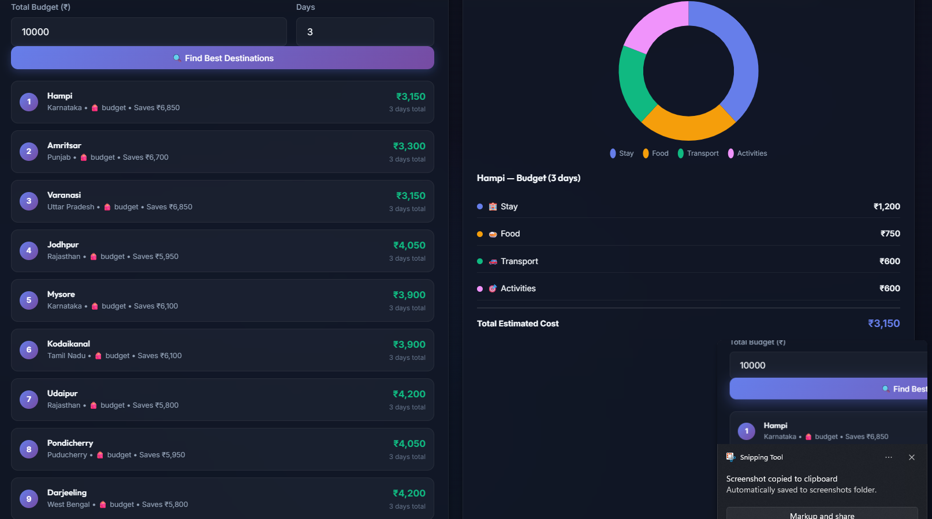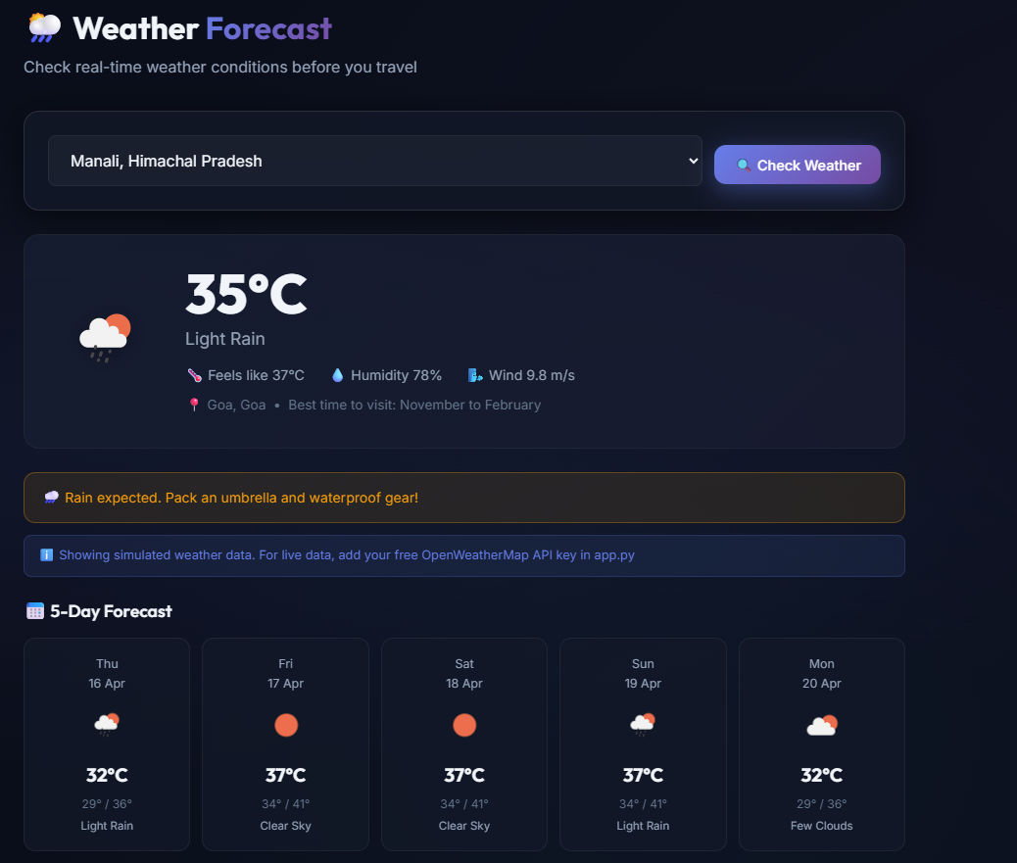
- Challenges Faced during the Project :
- Designing the Itinerary Algorithm: Distributing attractions logically into morning, afternoon, and evening slots while mapping them closely to dynamically selected user interests.
- Asynchronous API Management: Handling delayed responses from the OpenWeatherMap API and providing a seamless loading state for the user without blocking the UI thread.
- State Management in SPA: Maintaining the global state (current user, active tab, populated map markers) entirely using Vanilla JS without relyng on robust frameworks like React, avoiding unexpected DOM resets.
- Map Library Integration: Ensuring LeafletJS correctly resized and centered map bounds when the user seamlessly navigated into the "Explore" tab from a hidden CSS state.

11.References :

- Flask Documentation: https://flask.palletsprojects.com/
- OpenWeatherMap API Documentation: https://openweathermap.org/api
- LeafletJS Interactive Maps Guide: https://leafletjs.com/reference.html
- Chart.js Documentation: https://www.chartjs.org/docs/latest/
- MDN Web Docs (JavaScript/Fetch API): https://developer.mozilla.org/en-US/
12. Appendix
Setup & Execution guide:
- Clone the project or extract the zip file.
- Ensure you have Python 3.8+ installed.
- Open the terminal in the project directory and run: pip install flask requests werkzeug.
- Run the application: python app.py
- Visit http://localhost:5000 in your web browser.

13.Future Scope :

While VoyageAI operates impressively as a standalone planner, there are multiple avenues for future enhancement:
- Generative AI Integration: Integrate OpenAI (ChatGPT) or Google Gemini APIs to fetch live descriptions and craft highly unique, conversational itinerary texts instead of relying on a strict JSON database.
- Booking Integrations: Connect the system with flight (Skyscanner) and hotel (MakeMyTrip/Booking.com) APIs so users can directly book the plans projected in their itinerary.
- Collaborative Group Trips: Allow multiple authenticated users to edit the same trip plan simultaneously in real-time.
- Progressive Web App (PWA): Enable offline access so travelers can view their saved itineraries and maps even without an active internet connection on the go.
14. Conclusion:
Smart Travel Planner successfully overcomes the limitations of generic travel planning software by employing intelligent data filtering, algorithmic itinerary generation, and real-time environmental data visualization. Using a robust Flask backend combined with a dynamic client-side SPA architecture, the project provides an elegant, highly customized, and engaging travel planning experience. The system meets all defined objectives, bridging the gap between researching a destination and actively building an optimized, budget-friendly travel schedule, making it an impressive and functional standalone application.
*****************************************

